**Local Charity PACE Manningtree Wins Prestigious National Landscape Award**

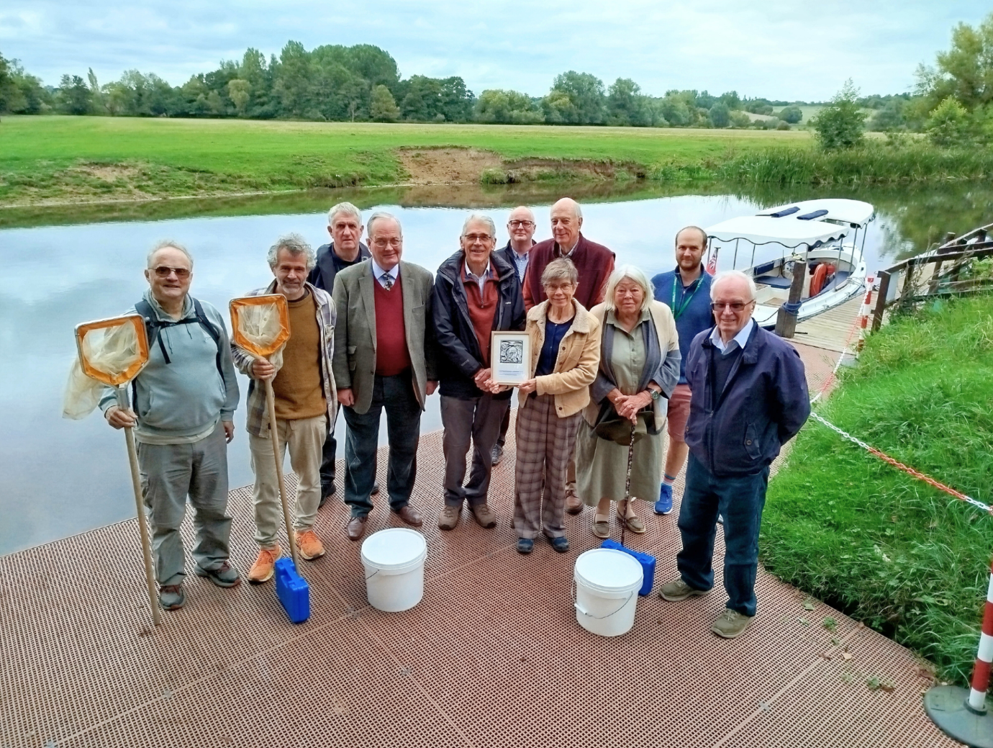

PACE Manningtree (Practical Actions for Climate and the Environment) has been named the winner of the Robert Erith National Landscape Award 2025, recognising the outstanding work of its volunteer Water Quality Team in protecting the River Stour.

The award, given annually by the Dedham Vale National Landscape and Stour Valley Partnership, celebrates exceptional contributions to conserving and enhancing the National Landscape and Stour Valley. This year, the judging panel voted unanimously for PACE, praising the team’s commitment to monitoring the river month after month, in all weathers, for over three years.

Protecting the Stour for wildlife and communities: Armed with waders, nets and sampling bottles, 15 volunteers from PACE check the river at five sites between Langham and Dedham. Their surveys reveal how healthy the river is, spotting problems early and gathering vital evidence of pollution.

John Hall, who coordinates the project, said:

> “Our volunteers have been out in the Stour in rain, shine, or frost. The data we collect is like an early-warning system — it shows where pollution is affecting wildlife and where it could put the river and its users at risk. This award is fantastic recognition of their hard work.”

The River Stour, at the heart of Dedham Vale, faces pressures familiar to other rivers across the UK — sewage spills, agricultural run-off and road pollution. PACE’s monitoring has already flagged three pollution incidents, helping professional ecologists from the Environment Agency come out to take action. The group also partners with the University of Essex to track the levels of harmful bacteria such as E. coli and Enterococcus which can cause stomach upsets for swimmers, paddleboarders and other river users.

Cllr James Finch, Chairman of Dedham Vale National Landscape Partnership said:

> “PACE’s Water Quality Team is an outstanding example of what dedicated volunteers can achieve. Their work is invaluable for the long-term health of the Stour and a real benefit to the communities and wildlife of this National Landscape.”

Founded in Manningtree, PACE is a charity working with local people to tackle climate change and biodiversity loss through practical, community-led projects. The award was formally presented to the group by Cllr James Finch, Chairman of the Dedham Vale and Stour Valley Partnership, and Robert Erith BEM TD DL, the former Chairman of the Dedham Vale National Landscape and Stour Valley Partnership, a lifelong advocate for the special landscape.

The presentation took place on the bank of the River Stour at The Boatyard, Dedham and then the group embarked on the electric-powered boat, Maria Constable, operated by the River Stour Trust, a beautiful, peaceful trip to Flatford and back, during which there were excellent sitings of the azure-blue Kingfisher, other riverine wildlife and various heritage features of the River Stour such as the Lintel Lock at Flatford.

You can find out more about the Robert Erith National Landscape Award at dedhamvale-NL.org.uk/awards. Learn more about the fantastic work of PACE at pacemanningtree.org.uk