CLEAN UP YOUR TOYS ON THE BEACH

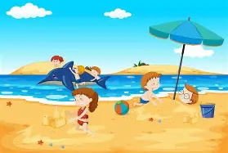

LET’S KEEP OUR BEACH TIDY & HAPPY

