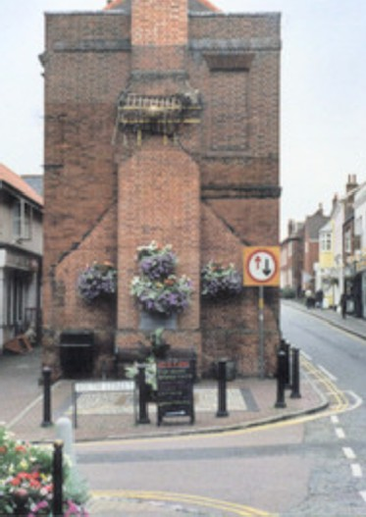


SPRING LITTER PICK SUNDAY

22nd MARCH 2026

Join us at the beach at 10 am for an hour and help us tidy up our town.

We have a limited number of litter pickers available... bags will be provided,
Please bring your own gloves. Children must be accompanied

**keep an eye on Facebook and the noticeboards for updates**

